**Computer Science TEST 1**

**Marks**: 30 Marks **Time**: 1 Hour 10 Mins

1. What are the Five Pillars/Features of OOP? Explain them in short. **5 Marks**
2. What is a Pointer? Write a C++ code to show a Function returning a pointer?

**1 + 3 = 4 Marks**

1. Define the following: **1 * 4 = 4 Marks**
2. Copy Constructor
3. Destructor
4. Linear Data Structure
5. Candidate Key
6. Write a C++ Program to show the working of Binary Search on an Array. **5 Marks**
7. In the given table, display the details of those items whose suppliers code is 22 or Quantity is more than 110. **2 Marks**

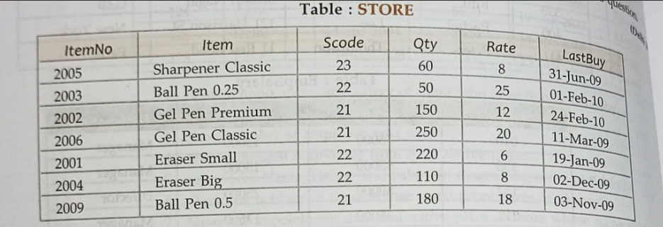

1. In the two tables First one named ITEM:

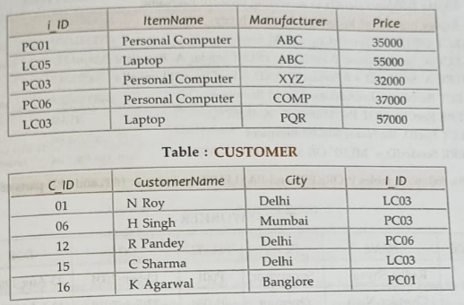

1. Display the Customer Name and the Manufacturer if the item exists in both the tables. **2 Marks**
2. Display the Name and maximum price and of each item. **2 Marks**
3. Convert the following into PostFix: **2 Marks**

P/(Q-R)*S+T

1. Write a C++ program of Addition of two Matrices: **4 Marks**

**Bonus Questions:**

1. Define Non-linear Data Structure and name some examples. **2 Marks**
2. Evaluate the Following PostFix Expression: **4 Marks**

8 2 3 * 1 / + 4 1 * 2 / +

------------------- x ------------------